Mozambique Drilling and Completion Development

Purpose
Project/Operating Information is designed to provide an overview of the key data pertinent to the Drilling and Completion Program on Rovuma, offshore Area 4 in Mozambique.
Although not exhaustive, the document should be sufficient to allow the Contractor to assess equipment specifications and services required. If the data required allowing this assessment is not included, the Contractor is encouraged to request further data as part of the clarification process.

General project description
Company’s development plan consists of the following:
- 9 wells x Oligocene Upper 361-2 (OU) OHGP gas producers
- 9 wells x Eocene Upper 397 (EU) OHGP gas producers
Company’s first well is targeted to spud in 2H/2027. Company will batch drill all 18 wells down to setting the 10-3/4” liner and then start the completion operations to drill the 9-1/2” hole and run the lower and upper completion equipment. Estimated target to start completion operations on first well is 1H/2029.
The primary targets are Oligocene and Eocene sandstones in structural and stratigraphic closures. Water depth is around 1550-1710 meters and target depths are 3600-4400 meters SSTVD.
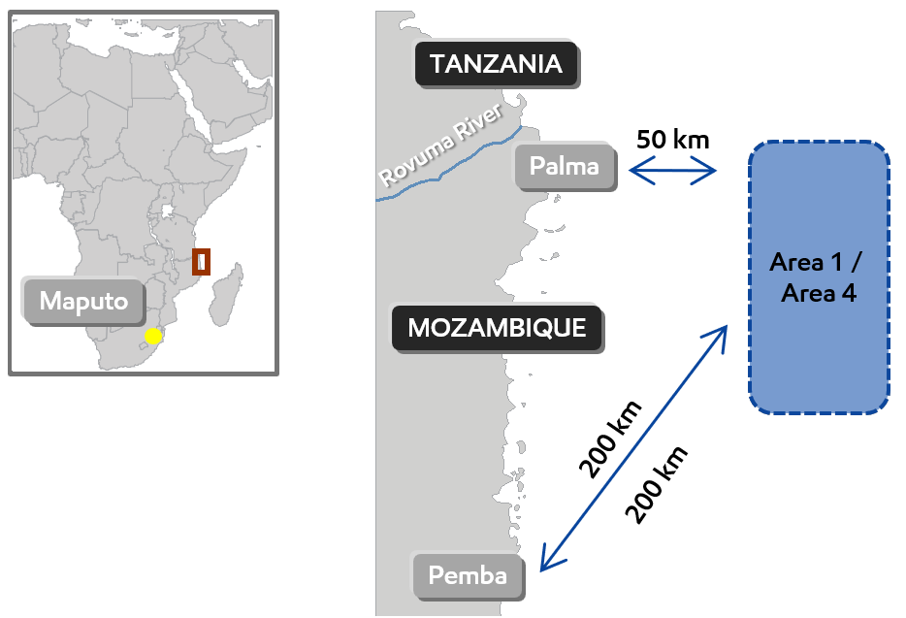
Figure 1. Area 4 location

Additionally, Company is currently evaluating prospects and may drill additional eight (08) wells x Oligocene Lower 385E (OLE) gas producers (Phase 2) in Mozambique.
Company’s interest offshore Mozambique is shown in Figure 2 below:
Galp
10%
Kogas 10%
ENH 10%
EM 25%
ENI 25%
CNPC 20%
MRV – 70% (Operator)
Area 4 Concession

Figure 2. Area 4 Concession Interest Split
All wells are planned to be drilled with a dynamically positioned drill ship with optional MPD installed and used if needed (TBD).
A marine shore base in Mozambique is yet to be determine but is planned to be used as the main location for the supply of drilling and completion equipment and services needed to support the drilling and completion operations. The logistics strategy is still under consideration and will be communicated once finalized.
For the purposed of this bid, Contractors are requested to consider Company’s shore base in Pemba, Mozambique for equipment delivery and support vessels to/from drilling unit and take into consideration synergies associated with utilization of equipment, facilities, personnel in the region and other Companies operating in the area.
Contractors are also encouraged to highlight efficiencies and cost savings available, if Contractor awarded with multiple scopes.
The transport of personnel to/from the drilling unit will be by helicopter or boat, and for purpose of this bid, assume Pemba area.

Well Design (Tentative)

Reservoir Information (18 single zone gas producers)
- Water depth: ~1550 – 1710m
- TVD: ~3600-4400m TVD RKB (~2000 -2800m BML)
- Reservoir Fluid: Gas with 0.2% CO2 and no H2S
- BHP/BHT for the two reservoirs:
  - OUS reservoir: ~5417 psi @ 3460m (~8.99 ppge) ~189deg F/ 88 deg C
  - EU reservoir: ~6510 psi @ 4210m (~9.06 ppge) ~249 deg F/ 121 deg C
- Gravel pack interval thickness: 90 - 150m

Trajectory Design
- Start around 2330m and Build rate ~2.5°/30m
- Hold inclination to TD with Max hole inclination is ~58º with average of ~44º
- Throw: OU max throw is ~1.4 km and EU max throw is ~1.7 km

Drilling Design - Hole size and Casing Setting Points
- Jet 36” conductor pipe to ~69m BML
- Drill 24” hole and run 20” to ~630m BML
- Drill 17-1/2” hole and run 13-5/8” Production casing between ~3000m – ~3500m TVD
- Drill 12-1/4” x 13-1/2” hole and run 10-3/4” production liner set at ~reservoir top with 150m overlap into 13-5/8” casing
- Drill 9-1/2” OH to TD and run screens

Completion Design Criteria (high-rate, high reliability, long duration, single zone)
- 9-1/2” OHGP for high-rate gas production (200+ mmscf/d)
  - Company’s NafPac using 5-1/2” APT (shunted screens)
  - Shunt tube gravel pack gel for 121 deg C
- 10-3/4” x 6” OHGP packer to be used as production packer – V0 Rating
- 7” fullbore H-XT with 2” annulus access (A-annulus)
- 7” 35 ppf 13 Chrome tubing string with 7” production equipment
  - SCSSV: 7” and setting depths 630m below mudline 2158m to 2330m TVD
  - DHPT: (2x tubing, 1x annulus side)
  - CIM: Below DHPT for scale inhibition

Schematic Example
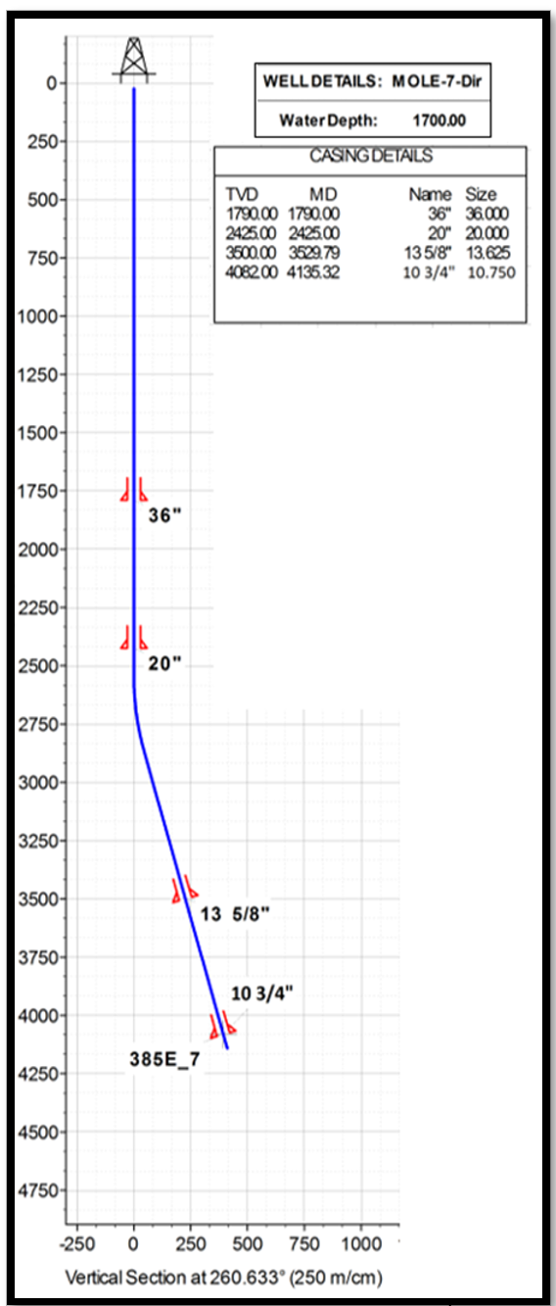
Figure 3. Completion Schematic and Well Trajectory (Example)

Well Execution Plan

